Project Report

On

Fake News Detection Using

Machine Learning

IN PARTIAL FULFILMENT FOR THE REQUIREMENT OF SECOND YEAR, PROJECT,
Masters of Computer Network and Information Security

Submi&ed by

M.tech-S.Y-[CNIS]

Under the guidance of

(Assistant Professor)


Department of Computer Science & Engineering
SHRI GURU GOBIND SINGHJI INSTITUTE
OF ENGINEERING AND TECHNOLOGY
VISHNUPURI NANDED - 431606 (M.S)
INDIA ACADEMIC YEAR: 2021-2022
Abstract

In our modern world where the internet is necessary, everyone relies on various online resources for news. Along with the increase in the use of social media platforms like Facebook, Twitter, etc. news spread rapidly among millions of users within a very short span of time. The spread of fake news has far-reaching consequences like the creation of biased opinions to swaying election outcomes for the benefit of certain candidates. Moreover, spammers use appealing news headlines to generate revenue using advertisements via click-baits. In this paper, we aim to perform different classification algorithms of various news articles available online with the help of concepts pertaining to Machine Learning. We aim to provide the user with the ability to classify the news as fake or real and also check the authenticity of the website publishing the news.
CONTENTS

1 | INTRODUCTION |  | 1-5
 | 1.1 | BASIC INFORMATION | 1
 | 1.2 | MACHINE LEARNING | 1
 | 1.2.1 | MACHINE LEARNING MODELS | 3-5
2 | LITERATURE SURVEY |  | 6-9
3 | PROPOSED METHODOLOGY |  | 10-18
 | 3.1 | PROBLEM STATEMENT | 10
 | 3.2 | PROJECT DETAILS | 10-13
 | 3.3 | PROCESS FLOW | 13-20
4 | REFERENCES |  | 21

CHAPTER 1

INTRODUCTION

1.1 BASIC INFORMATION

Fake news's simple meaning is to include information that leads people to the wrong path. Nowadays fake news spreading like water and people share this information without verifying it. And this type of news are spread for personal reasons or political agendas and so on. So it is necessary to detect fake news.

Many scientists believe that fake news issue may be solved by means of

machine learning and artificial intelligence. Basically, machine learning is

a technique in which computer program learn from experiences or past

experiences. Then specifically related to that it performs the task. So in

this project, Our goal is to develop a best model that classifies a given

news article as either fake or true. It can be detected using various machine

learning techniques.

1.2 MACHINE LEARNING

Machine Learning is a subset of Artificial Intelligence. It is a set of algorithms that train on a data set to make predictions or take actions in order to optimize some systems.

It is a technique in which computer program learn from experiences or past experiences. Then specifically related to that it performs the task.
Machine Learning algorithm create model using sample data or training data. Which takes the decision or prediction to perform the task. Then model checks the accuracy of that prediction, if accuracy is acceptable and prediction is correct, then machine learning algorithm

gets deploy. But if accuracy is not acceptable then model again get trained until accuracy doesn’t get accepted.
In machine learning whatever the processes are involved are similar to data mining and predictive modeling.

- Data mining is the process of finding the patterns from the large dataset in which machine learning, statistics, and database systems are used. It is also known as KDD(Knowledge discovery in databases).

- Predictive Modeling is the process of predicting future outcomes by using data mining and probability.

It uses mathematical module to find out hidden pattern from the data. This solves the real life problem or business problem. Machine Learning do complex task easily. For example face detection, self driving car, Alexa, etc.

Machine learning algorithms has three parts:-

- Input

- Output

- Objective Function or Performance matrix

The steps involved in machine learning are:-

- Problem Identification

- Data Collection and validation

- Model Building

- Feedback
1.2.1 MACHINE LEARNING MODELS

In Machine Learning, techniques and data are more important, but to identify the type of problem (supervised or unsupervised) is equally important.


Machine Learning
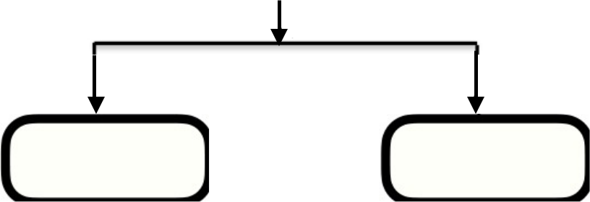

Supervised Unsupervised

Fig 1.1 Types of ML

Supervised Learning:-

In this input and output are already available. On the basis of this input and output or labeled data model is created and on that model new input are given and checked whether valid output is coming or not. In this model machine knows the features.

Supervised Learning are,

- Already Tagged Data

- Features and labels present

There are two types of supervised Learning:-

• Classification:-

- Classify which label a given set of features belongs to.

- This algorithm is used when there are limited number of answers Like, yes or no, 0 or 1, true or false, etc.

For example, Is it cold? -> Yes or No
- In these algorithm we have only two outputs. So, when there are only two outputs (only two choices) then that type is called as 2 class classification algorithm. But if there are more than two choices then this type is called as multi class classification.

- To solve the classification problem the algorithms required are, - Logistic regression

  - K-Nearest Neighbors (KNN)

  - Support Vector machine (SVM)

  - Naive Bayes

  - Decision Tree Classification

  - Random Forest Classification

• Regression :-

- Find out the value of the label using previous data.

For example, What will be the temperature tomorrow?

So the output will be suppose, 28.

- To solve the regression problem the algorithms required are,

  - Linear Regression

  - Multiple Linear Regression

  - Polynomial Regression

  - Support Vector Regression

  - Decision Tree Regression

  - Random Forest Regression

Unsupervised Learning:-

All a machine knows is the data in front of it. No Features, No Labels.
Machine seeing the data for the first time.

In this model,

- Data are not already tagged

- Features and labels not present
- Training not done

- Clustering:- Discover the inherit groupings in the data, such as growing customers by purchasing behaviour. There are two types of algorithm used for clustering and they are,

  - K-Means Clustering

  - Hierarchical Clustering

- Association:- Association rule learning problem, such as people that buy X also tend to buy Y.

Algorithm used for association are, - Apriori

    - Eclat

To know how a problem cane solved using machine learning models, some of the examples are:-

- Is this person is diabetic? (Yes or no) Algorithm used will be Classification Algorithm.
- Is this A or B?

Algorithm used will be Classification Algorithm 3. Is this weird?

Algorithm used will be Anomaly Detection Algorithm.

4. How many?

Algorithm used will be Regression Algorithms.

5. How is this organised?

Algorithm used will be Clustering Algorithm.
CHAPTER 3

PROPOSED METHODOLOGY 3.1 PROBLEM STATEMENT

- The goal of the project is to :

  - Prepare the data-set using several methods to train the model.

  - Build a model which can give high accuracy of predicting the fake news.

- Requirements:

- SOFTWARE : Anaconda navigator's Jupiter notebook

- WEBSITE : Here Dataset is taken from Kaggle site.

  - LIBRARIES : Pandas, Numpy, Matplotlib, Seaborn, Scikit Learn, etc.

- So, by observing this problem statement, we can say that it comes under Classification technique which is a type of Supervised Machine Learning, here the model is built using different classification algorithms.

3.2 PROJECT DETAILS

It is a Machine Learning project in which we need to predict whether a given data is fake or real. Since it comes under the Classification technique which is a type of Supervised Machine Learning, here the model is built using different classification algorithms like Logistic regression, K-Nearest Neighbors, Naive Bayes , and Support Vector Machine. The model, which will give higher accuracy out of all in predicting whether the given data is fake or real will be chosen. That model or algorithm will be use further for predicting the false or real news.
Libraries used in this project are:-

- NumPy :

- Here, Num means numeric and Py means python.

- It is a scientific computing library for python.

- It supports multi-dimensional array. It is used to represent the large number of data in the form of array.

- NumPy Library is used for numeric calculation.

- To store data it uses less memory. It is very convenient and process fast.

- NumPy for Machine Learning:- Any machine learning model can’t directly perform operation on images so for that images are converted into the numpy array format then machine learning can perform operations.
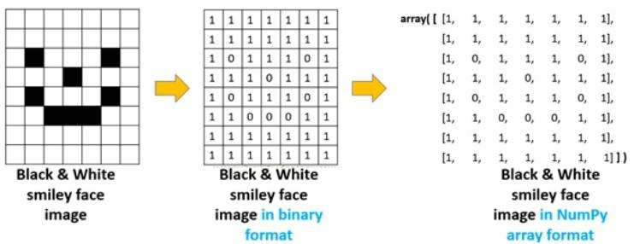

Fig 3.2.1 NumPy for Machine Learning

Here in fig., image is converted to binary format(numeric format) then in NumPy array format. Now machine learning model can perform operation on this format.

- Pandas:

- Pandas is a powerful python data analysis toolkit.

- Pandas is used for data manipulation, analysis and cleaning.

- Open Source

- For data manipulation it is a fast and efficient data frame.

- It can read different types of formats like, csv, JSON, etc.
- Importance of Pandas :- Suppose in data science projects, to find useful insights or patterns from raw data firstly raw data should be in proper format. This is known as data preprocessing. In data preprocessing panda libraries are used. To prepare and process the data this, library is very fast and efficient. This library have many features like, it can use for handling missing values, reshaping the datasets, etc.

•SKLearn:

Using SKLearn for machine learning:-

- Simple and efficient tools for data mining and data analysis.

- Accessible to everybody and reusable in various contexts.

- Built on Numpy, Scipy, and Matplotlib.

- Open source, commercially usable-BSD license.

•Matplotlib:

- Matplotlib is a 2D and 3D plotting python library.

- This library is used when there is a bulk of data at that time we can transform that data in a graphical representation and can analyse the data easily.

- It is use to create high quality graph.

- Matplotlib graphs are Histogram, Bar charts, Scatterplots, etc.
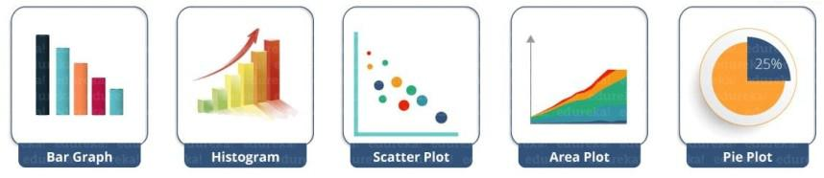

Fig 3.2.2 Matplotlib Plots

• Seaborn :-

- It is a python library use for data visualization. This library is build using matplotlib library.
- It is use for statistical library.

- Seaborn graphics are Heatmap, Pair plot, Facet grid, etc.

- Dependency of Seaborn:- Seaborn library is dependent upon Python, NumPy, Pandas, Scipy, Matplotlib.

3.3 PROCESS FLOW

This is the system architecture,


Data collection

(Dataset contains of

statements and labels)

Data Preprocessing
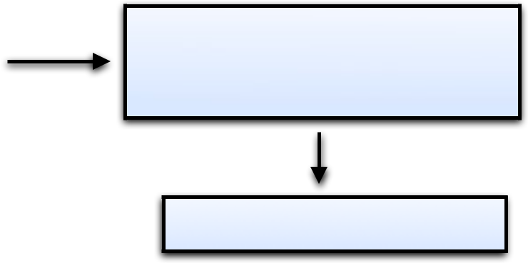
(data cleaning, missing values,

stop words removal, Lemmatisation)

Data Visualization
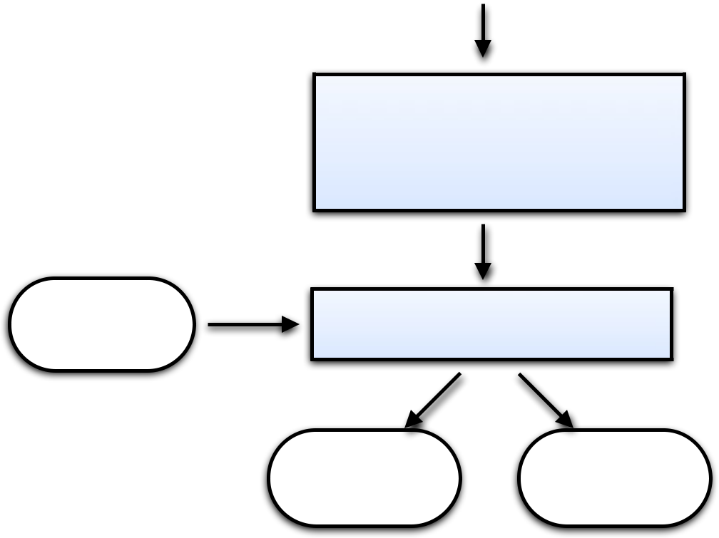

Training Classifiers

(Logistic Regression, Random

Forest,Naïve Bayes,

Long Short-Term Memory, SVM)

User Input

Final Classification Model

Fake News True News

Fig 3.3.1 System Architecture

Implementation STEPS:

Step by Step implementation of the project:-

• Step 1:-
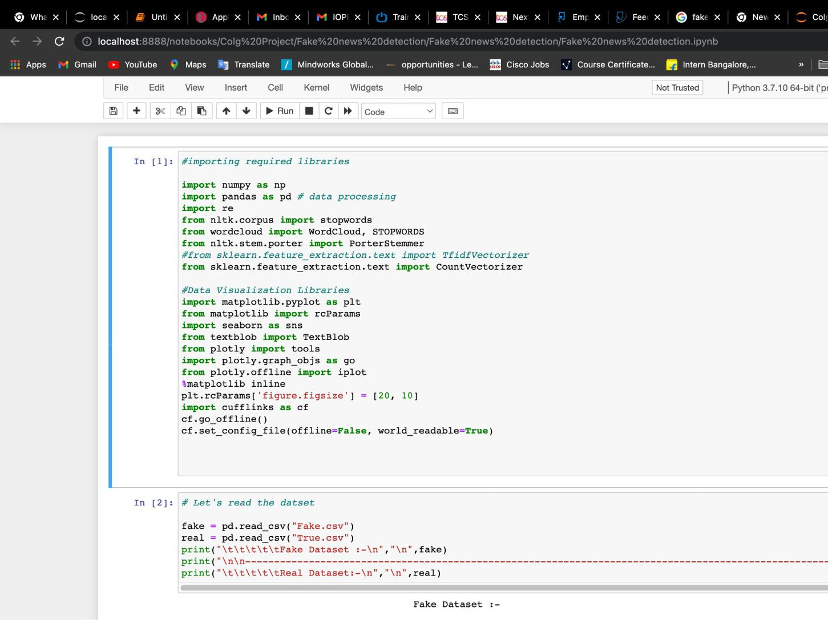

Import all the required libraries such as numpy, pandas, etc.

For example,

import numpy as np

This Libraries will be used for “Data Preprocessing” and “Data

Visualization”Step.

Here,

- To read any dataset we need pandas library.

- Numpy can be used to perform a wide variety of mathematical operations on arrays.

- we will use functionalities of the ‘nltk‘ library named Removing Stopwords, Tokenization, and Lemmatization.
This is the syntax one should import libraries like this. But this libraries should be installed first then import the libraries.

Step 2:-

Second step is to read the dataset and stored it into new variable.

Here, Dataset is taken from kaggle site (https://www.kaggle.com/
clmentbisaillon/fake-and-real-news-dataset).

In this, data there are two datasets,

- Fake.csv : This dataset contains a list of fake news.

- True.csv : This dataset contains a list of Real news.

To read any dataset we need pandas library. In this project, datasets are in

the csv format. Here csv means comma separated value and to read the data of csv format we use,

read_csv()

For example, In this Project
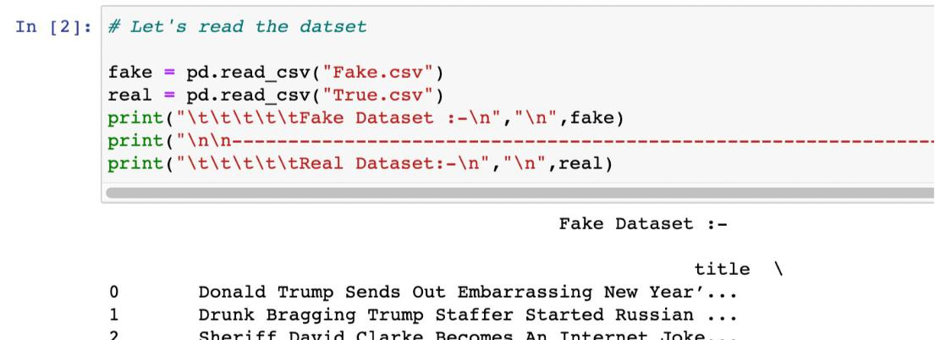

• By using head() function we can see the first n rows of the datasets.

In this Project there are two datasets so, Below screenshot shows the first 5 rows of the fake.csv and true.csv datasets.
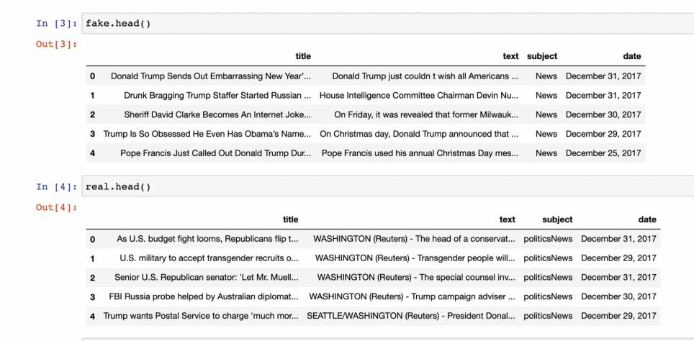
• Step 3:-

Next step is “Data Preprocessing step”

In this process, raw data or original data are purified. For data preprocessing the python libraries like NumPy, Panda, Sklearn, etc are used.

The steps in this process are,

1. Data Cleaning:

In this step, missing data are filled using nan or 0. Any row who’s heading

or label is not given are ignored or removed. Any type of irrelevant data

are removed. After this, noisy data (meaningless data or corrupted data)

are deleted or removed.

2. DataTransformation:

In this step, feature scaling is done. In this scikit-learn library is used. Normally for solving classification problem data transformation is used. 3. Dimensionality Reduction:
In this step, dimensions are reduced like 3D data is converted to 2D data.

So in this way data are analysed.

• In this step,

we will start from checking the shape of the datasets.

This means, In “fake.csv”dataset there are 23481 rows and 4 columns.

In “True.csv”dataset there are 21417 rows and 4 columns.
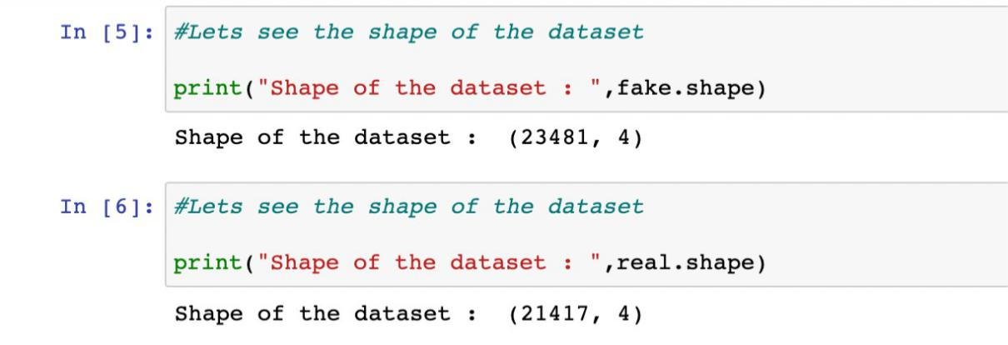
- Now we will combine the two datasets. That is we will concatenate the dataframes.

After this step, The dataset will look like this,
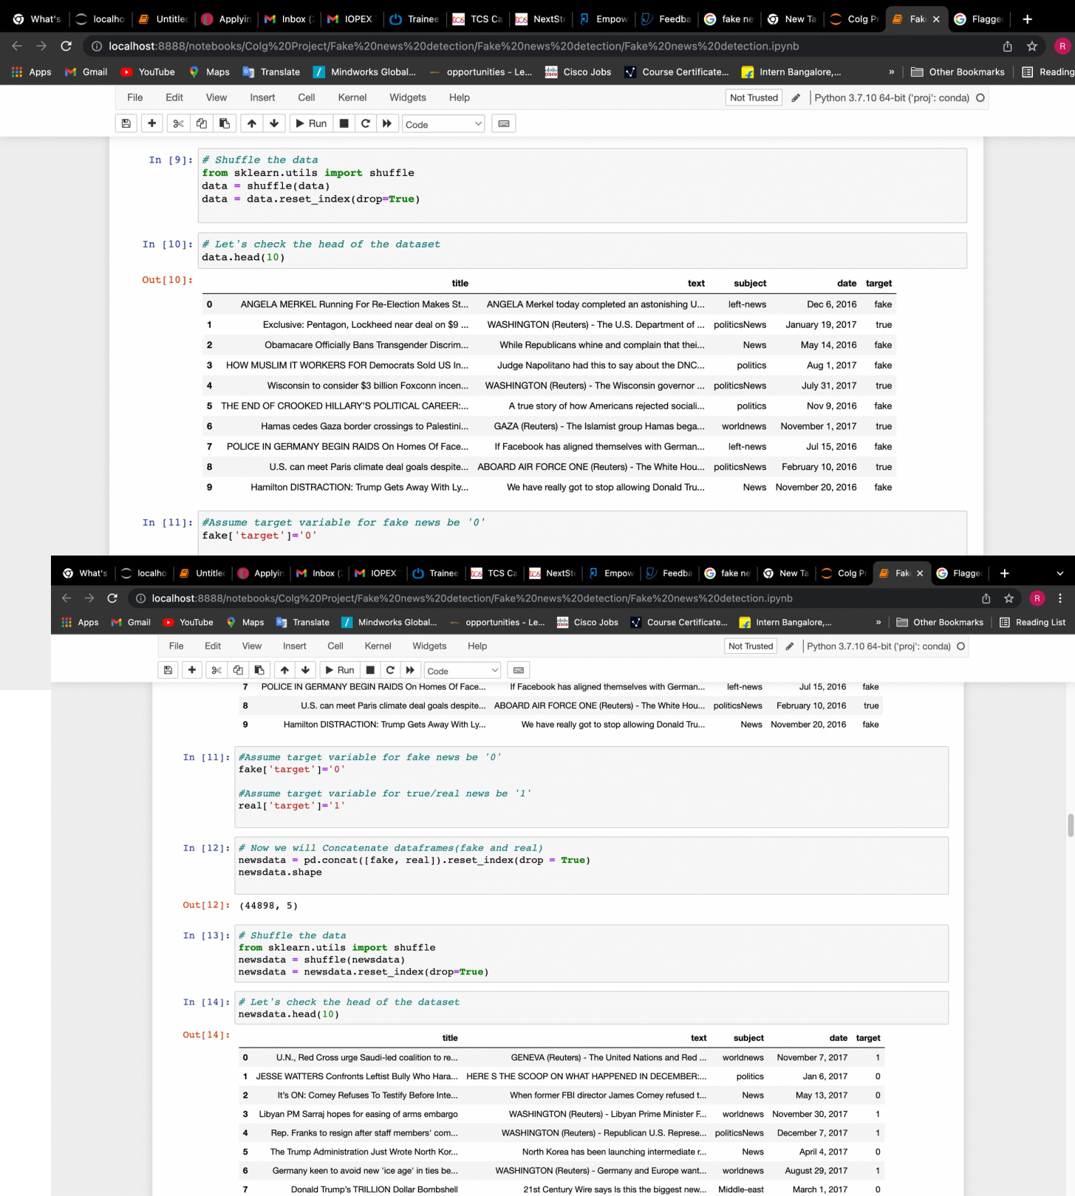

Then we will assume the target variable for,

Fake news -> 0

True news -> 1

• Now, we will check is there any null values or missing values,

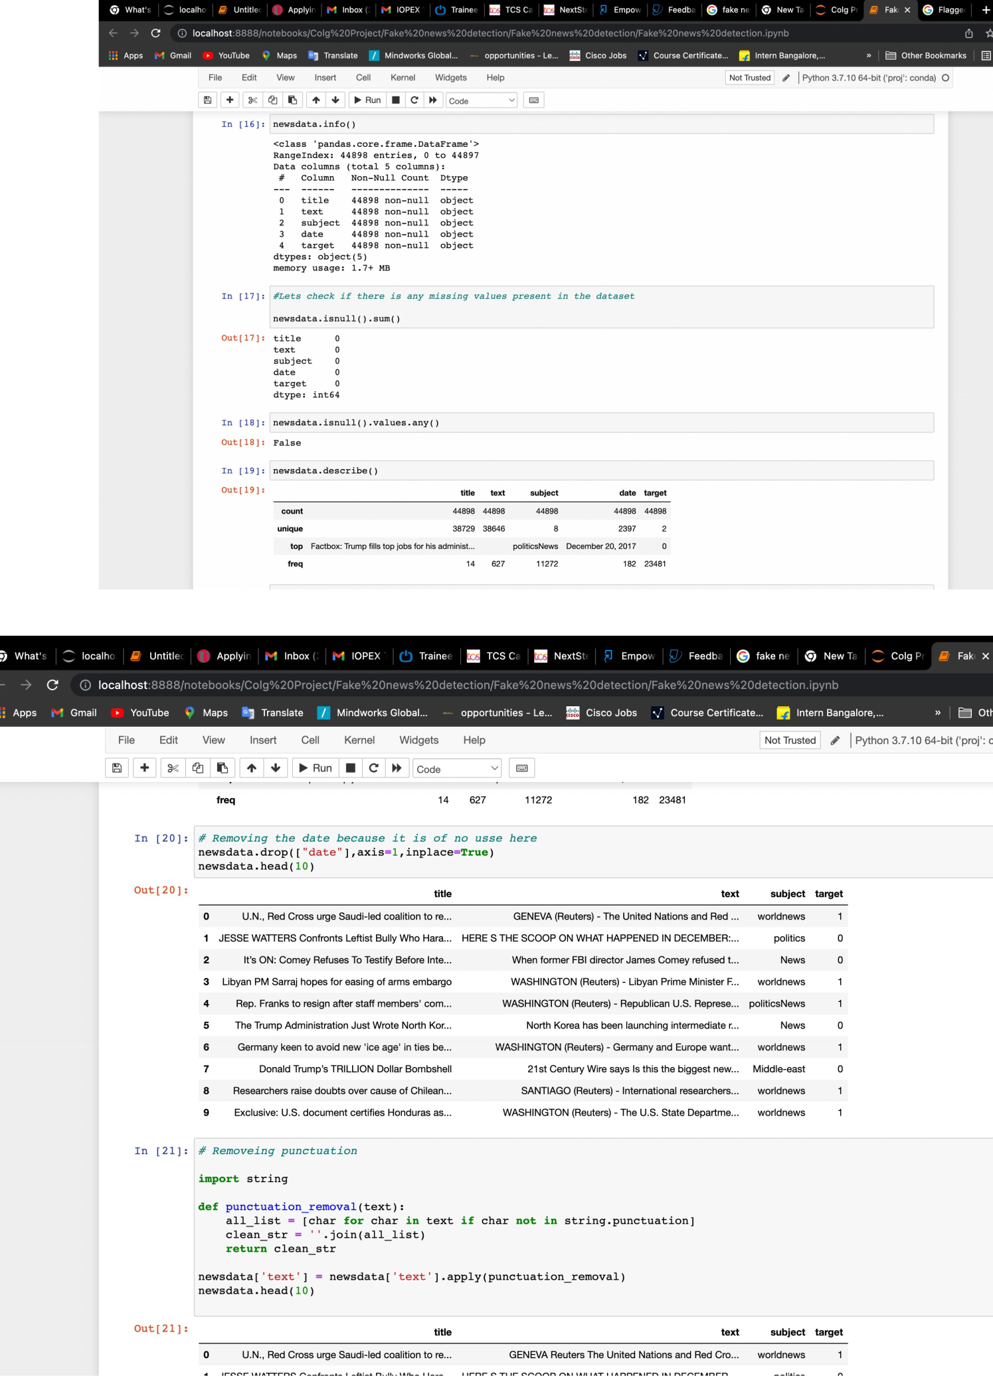

So, In this dataset there is no missing values or null values.

• Now we will remove the “date” column because for analysing this

column is of no use. After removing, dataset will look like the below screenshots,

• Removing Punctuation,

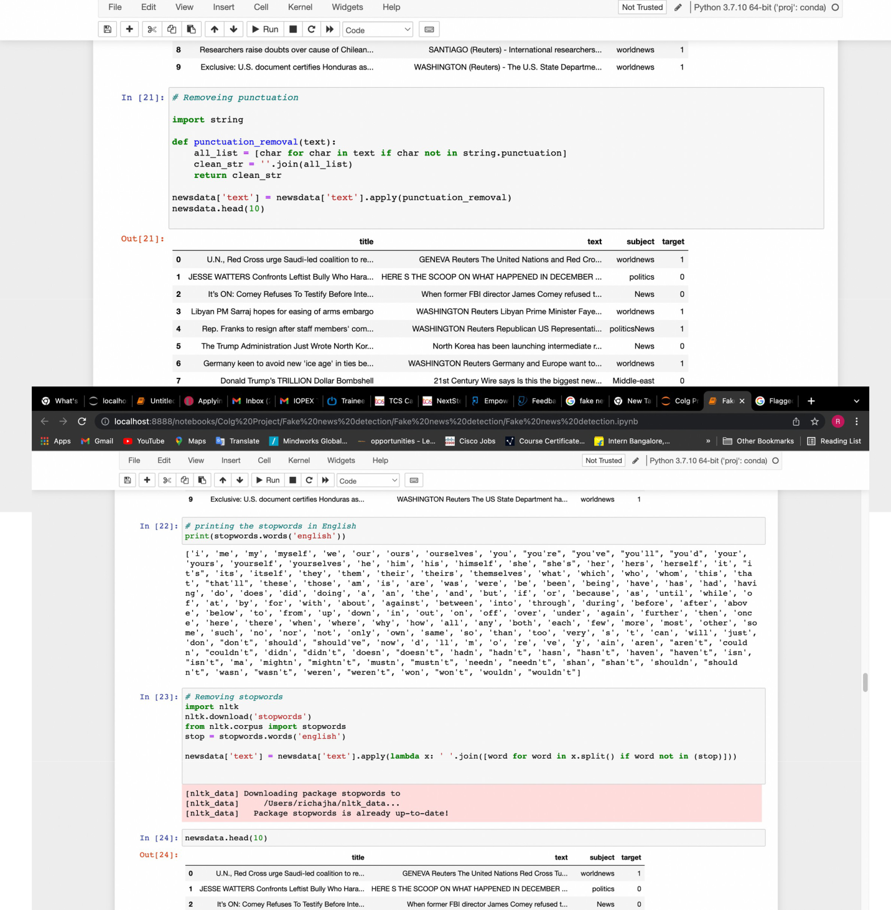

• We will remove all the stop words, because stop words are the words

which occurs frequently and that are of no use. Like; the, a, on, for, etc.

• Step 4:-

Next Step is “Data Visualization ”.

Data visualization is a graphical representation of data. Here, data are transformed to piecharts, graphs, bar graphs, histograms, etc. For data visualization python libraries like matplotlib, seaborn, etc are used.

CHAPTER 4

REFERENCES

- Kai Shu, Amy Sliva, Suhang Wang, Jiliang Tang, and Huan Liu, “Fake News Detection on Social Media: A Data Mining Perspective” arXiv:1708.01967v3 [cs.SI], 3 Sep 2017

- M. Granik and V. Mesyura, "Fake news detection using naive Bayes classifier," 2017 IEEE First Ukraine Conference on Electrical and Computer Engineering (UKRCON), Kiev, 2017, pp. 900-903.

- Fake news websites. (n.d.) Wikipedia. [Online]. Available: https:// en.wikipedia.org/wiki/Fake_news_website. Accessed Feb. 6, 2017

- Conroy, N., Rubin, V. and Chen, Y. (2015). “Automatic deception detection: Methods for finding fake news” at Proceedings of the Association for Information Science and Technology, 52(1), pp.1-4.

- Markines, B., Cattuto, C., & Menczer, F. (2009, April). “Social spam detection”. In Proceedings of the 5th International Workshop on Adversarial Information Retrieval on the Web (pp. 41-48)

